EXERCISE 9
1. List the minimum perks package.
SELECT MIN(perks)
FROM employee_data;
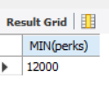
2. List the maximum salary given to a "Programmer".
SELECT MAX(salary)
FROM employee_data
WHERE title = 'Programmer';
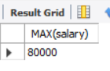
3. Display the age of the oldest "Marketing Executive".
SELECT MAX(age)
FROM employee_data
WHERE title = 'Marketing Executive';
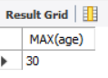
4. (Tricky!) Find the first and last names of the oldest employee.
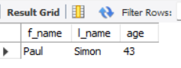
SELECT f_name, l_name, age
FROM employee_data
ORDER BY age DESC
LIMIT 1;

